**Introductory Lab**

**A first C# windows application**

1 START / programming -> Visual Studio

From Project Types: - select Visual C# Projects

New Project

From Templates: - select Windows Application

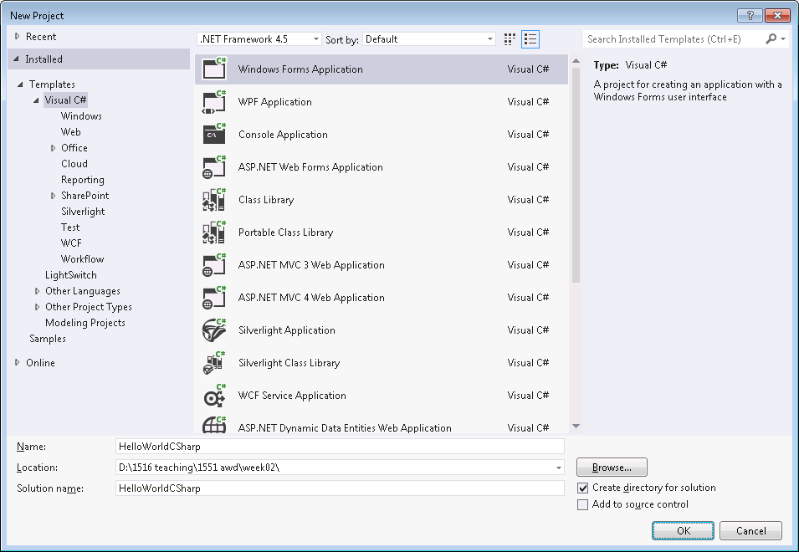

In Location: - browse to where you want to store your C# projects

In Name: - choose some name e.g. HelloWindowsWorld

Make sure “Close Solution” is checked

Click OK

.2 Should display Form1 in design mode

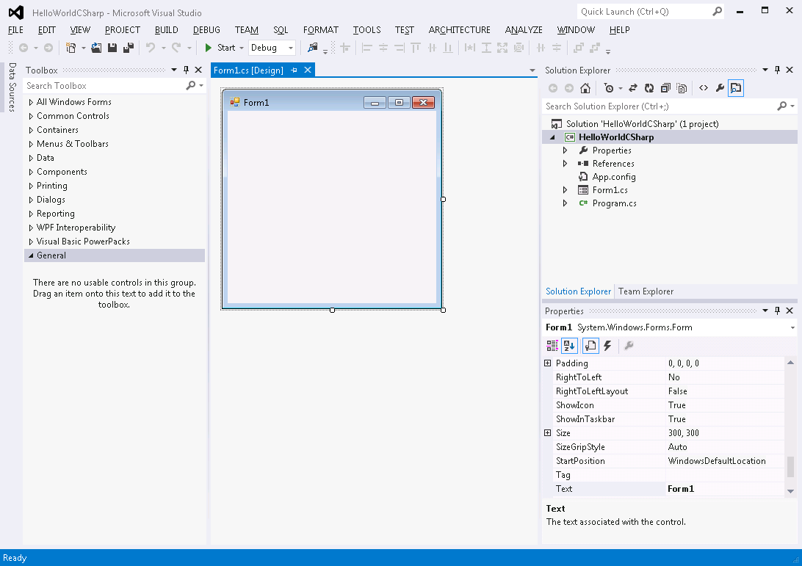

Right click on the form and select “View Code” to see the code for the class. You can see the code using the tab “< >” at the top of the Solution explorer window.

To see the design view, double click on the icon of the Form

The code should look something like:

using System;

using System.Collections.Generic;

using System.ComponentModel;

using System.Data;

using System.Drawing;

using System.Text;

using System.Windows.Forms;

namespace HelloWindowsWorld

{

public partial class Form1 : Form

{

public Form1()

{

InitializeComponent();

}

}

}

It is a “partial class” because a lot of the code generated for class Form1 is hidden from you in another file called Form1.Designer.cs. You can access this file from **Solution Explorer** panel on the right. You may need to expand the Form1.cs node in order to see it.

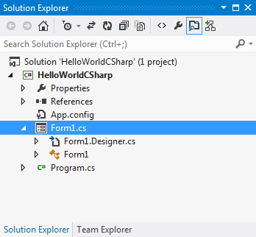

You shouldn’t normally need to edit the code in Form1.Designer.cs.

In the Solution Explorer you can also see that another class file has been generated called Program.cs. If you look at the code for this you can see that it is the program that creates and instance of Form1and runs it.

2.3 Select the Form1.cs design view (DoubleClick on the form).

If the Toolbox is not already on display select View->Toolbox. You can “pin” the toolbox so it shows all the time

Click on “All Windows Forms” in the toolbox to display some standard GUI widgets. Add a label and a button to the form by dragging them

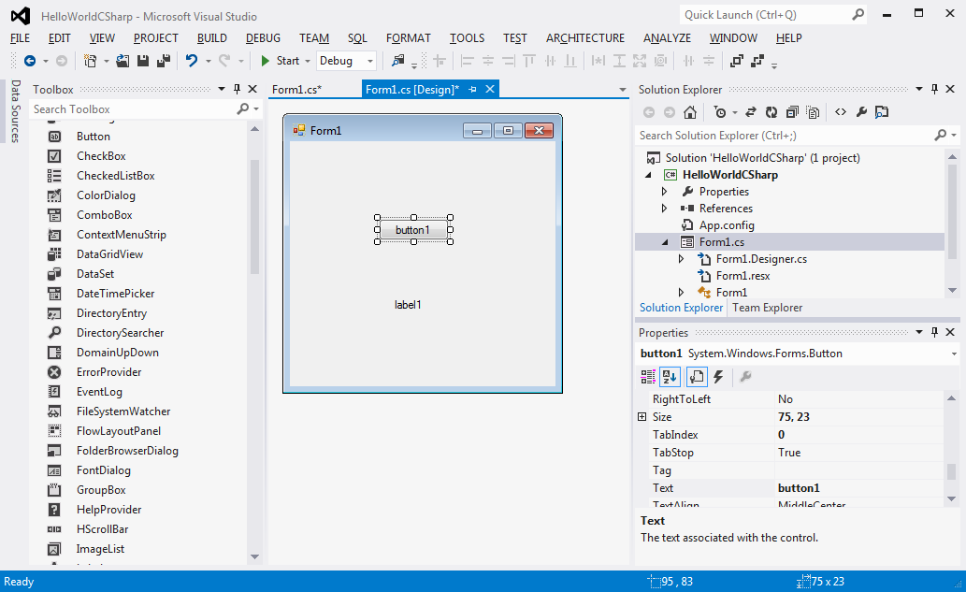

Check if the Properties panel is not showing, Go to View->Properties Window

Use the Properties panel to change the text of the button to “click me” and the name

To”ClickMe”

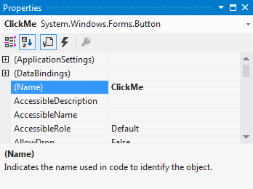

Change the name of the label to lblHello

Select the button on the form.. Double click on it. This should show the code:

private void ClickMe_Click(object sender, EventArgs e)

{

}

Inside the { } add in some code to display hello world in the label e.g.

lblHello.Text = "hello world"; // This is an assigment

Build and run the program by clicking on the Start button at the top ( with a green arrow )

